**Unit 7 Will people have robots?**

**单元教学目标**

话题：未来的生活（Life in the future）

功能：能谈论对未来的预测（Make predictions）

A: What will the future be like?

B: Cities will be more polluted. And there will be fewer trees.

A: Will there be world peace?

B: Yes, I hope so.

语法：

1. 能正确使用一般将来时谈论对未来的预测（Future with will）

A: Will people use money in 100 years?

B: No, they won’t.

Kids will study at home on computers. They won’t go to school.

2. 能正确使用more, less, fewer表示数量（Quantities with *more, less, fewer*）

There will be more pollution/people.

There will be less free time.

There will be fewer cars and more buses.

We can use less water and plant more trees.

词汇和常用表达：

1. 能正确使用下列词汇：（Curriculum words）

paper, pollution, future, environment, planet, earth, part, peace, sea, sky, apartment, space, human, factory, shape, side, holiday, word, pollute, plant, believe, disagree, fall, dangerous, possible, impossible, already, even, probably, inside, during

1. 能正确使用下列常用表达：(Useful expressions)

play a part, space station over and over again, hundreds of, fall down, look for

1. 能够认读下列词汇：(Non-curriculum words)

prediction, astronaut, rocket, servant

语音：

1. 通过朗读训练继续巩固对句子重音的把握
2. 通过跟读模仿感知、学习使用不完全爆破

学习策略:

1. 通过与一般现在时、一般过去时的对比学习一般将来时

2. 学习使用归类的方法记忆词汇

3. 在阅读中尝试概括段落大意，加强篇章的整体理解

文化知识:

1. 了解当今世界环境污染问题

2. 了解未来机器人的发展趋势

**Section A 1 (1a-2d)**

一、**教学目标：**

1. 能掌握以下单词：paper, pollution, prediction, future, pollute, environment, planet, earth, plant, part, play a part

2. 能掌握以下句型：

⑴ Kids will study at home on computers.

⑵ Kids won’t go to school.

⑶ —Will people have robots?

—Yes, they will. / No, they won’t.

⑷ —Will there be less pollution?

—Yes, there will. / No, there won’t.

(5) —What can we do?

—We can use less water and plant more trees.

(6) There will be fewer trees and the environment will be in great danger.

3. 能了解以下语法：

一般将来时 will

4. 学会表达自己对未来的看法；学会谈论自己未来的打算。

二、**教学重难点**

1. 学习一般将来时态的意义和结构。

2. 学习There be句型的一般将来时态的结构。

3. 学习more/fewer；more/less的用法。

**三、教学过程**

**Ⅰ. Words and expressions**

Present the new words and expressions.

**Ⅱ. Warming up**

1. Present the picture in 1a, and let Ss talk about the questions:

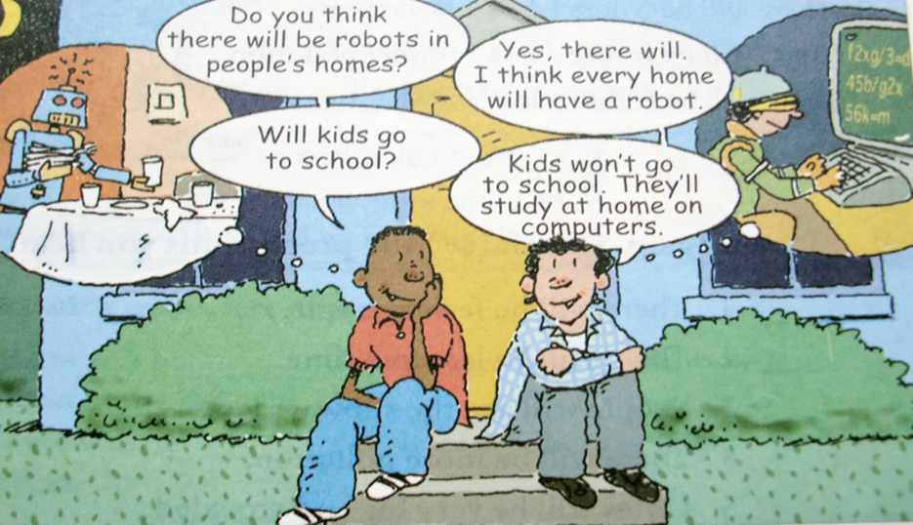

1) Where are the two boys?

2) What are they talking about?

3) Can you describe the two small pictures?

4) Do you think these situations (robot helping us at home; studying math on computer) are happening now or will happen in the future?

2. Discussion: How will the world be different 100 years from now?

Let Ss use “will …” to talk about or predict the future.

**Ⅲ. Work on 1a**

How will the world be different 100 years from now? Read the predictions in 1a.

Check A for agree or D for disagree.

**Ⅳ. Listening**

1. T: Now listen to the recording and circle the predictions you hear in 1a.

A D 1. People will have robots in their homes.

A D 2. People won’t use money. Everything will be free.

A D 3. Books will only be on computers, not on paper.

A _ D 4. Kids won’t go to school. They’ll study at home on computers.

A D 5. There will be only one country.

A D 6. People will live to be 200 years old.

2. Play the recording again. Check the answers with the Ss.

3. Show the tapescripts and let Ss know the use of “will”.

“will + 动词原形”表示将来某个时间要发生的动作或存在的状态

否定句式: will not + 动词原形, will not 可缩写为won’t

**Ⅴ. Pair work**

1. Let Ss read the conversation in 1c.

2. Then let Ss ask and answer questions about the predictions in 1a. Then make their own conversations.

3. Let some pairs act out their conversations.

**Ⅵ. Listening**

1. Pre-listening

* How many people are there in the picture?
* What are they talking about?

Work on 2a

2. Read the sentences in 2a. Tell Ss they will listen to some sentences. They should listen and circle the words in the bracket.

1) There will be (more/less/ fewer) people.

2) There will be (more/less/fewer) free time.

3) There will be (more/less/fewer) cars.

4) There will be (more/less/fewer) pollution.

5) There will be (more/less/fewer) trees.

3. Play the recording for the Ss to listen and circle the words.

4. Play the recording again to check the answers.

5. There be结构在一般将来时中的运用:

There will be + more/less/fewer + 名词

more (many和much的比较级) + 可数名词或不可数名词

less (little的比较级) + 不可数名词

fewer (few的比较级) + 可数名词

Work on 2b

1. Let Ss read the sentences below. Explain some main sentences for the Ss. Make sure they know what to do.

____ 1. There will be fewer people.

____ 2. There will be less free time.

____ 3. People will use the subways less.

____ 4. There will be more pollution.

____ 5. Cities will be very big and crowded.

2. Play the recording for the Ss to check the predictions they hear.

3. Play the recording again and check the answers.

**Ⅶ. Pair work**

1. Make conversations about the predictions in 2a and 2b.

2. Ask some pairs to act out their conversations.

**Ⅷ. Reading**

1. Listen and read the conversations and answer the questions:

1) What will the future be like according the book about the future?

2) What can people do to save the earth?

2. Let Ss role-play the conversation.

**Ⅸ. Language points**

1. Do you think there will be robots in people’s homes?

你认为人们家里将会有机器人吗？

1) 含有宾语从句的主从复合句

本句是一个含有宾语从句的主从复合句，do you think 是主句，there will be…是宾语从句。如果do you think 放在句中，则为插入语，常放在疑问词之后，结构为：疑问词+ do you think + (主语+)谓语+其他成分？

e.g. Do you think it’s necessary to discuss our plan?

Which do you think is the best restaurant?

2) there will be… 将有……；会有……

是there be 句型的一般将来时，可以与“There is / are going to be …”进行句式转换。

e.g. There will be a film this afternoon.

=There is going to be a film this afternoon.

there be 句型中的主谓一致遵循“就近”原则，即be动词和最靠近它的名词在数上保持一致。

e.g. There is an umbrella and two magazines on the table.

There are two magazines and an umbrella on the table.

【语境应用】单选

In the near future, there __________ self-driving cars in our city.

A. is B. was C. are D. will be

2. Will people use money in 100 years?

100年以后人们还会使用钱吗？

in 100 years 在100年以后

其中in为介词，其后跟一段时间表示“在……之后”，通常用于一般将来时。

e.g. I’ll have some breakfast ready in a few minutes.

辨析：in+时间段/ after+时间段

e.g. —How soon will your mother finish cooking dinner?

—In an hour.

—When did he receive her letter?

—After five weeks.

【语境应用】单选

—Shall we stop and wait for others?

—Sounds good. I think they will catch up(赶上) ________ a few minutes.

A. during B. after C. for D. in

3. What’s your prediction about the future?

future *n*. 将来；未来

in the future (在)将来；(在)未来

e.g. This may not happen in the future.

in future = from now on 今后；从现在起

e.g. I asked her to be more careful in future.

**Ⅹ. Summary**

live to be ... years old 活到……岁

in 100 years 一百年以后

fewer trees 更少的树木

be in great danger 处于极大危险之中

move to 搬到；搬迁

on the earth 在地球上

plant more trees 种更多的树

save the earth 拯救地球

**Ⅺ.Exercises**

**Ⅰ. 根据句意及所给首字母提示，补全所缺单词。**

1. Water is important to all living things on the e                 , so we should save water.

2. Riding a bike is good for health. It can also help reduce (减少) air p                 .

3. I need some p                  and a pen to write a letter (信).

4. Nobody knows what will happen in the f                 .

5. Each child wants to have a happy home e                 .

**Ⅱ. 根据汉语意思，完成英语句子，每空一词。**

1. 你将在这台手术中发挥重要作用。

You will _______ _______ _______ _______ _______ this operation.

2. 我希望50年后世界和平。

I hope there will be world peace _______ _______ _______.

3. 她的爷爷奶奶都活到了九十多岁。

Both her grandpa and grandma _______ _______ _______ _______ _______

years old.

4. John开车如此快以至于我感到有生命危险。

John drove so fast that I felt my life was _______ _______.

5. 他们卖掉了房子，搬到了一个小点儿的房子。

They sold their house and _______ _______ a smaller one.

**Homework**

写出几个对未来的预测，越多越好！

I think … in 100 years.

**Section A2 (Grammar Focus-3c)**

一、**教学目标：**

1. 学习掌握下列词汇：peace, sea, build, sky

2. 进行一步复习巩固运用Section A 部分所学的生词和词组。

3. 进一步运用所学的知识来陈述自己对将来的看法；学会谈论自己的对将来的预言。

4. 掌握情态动词will来表达一般将来时态这一语法知识。

5. 掌握 more, less, fewer + 名词的用法。

二、**教学重难点**

1. 进一步学习运用所学的知识来陈述自己对将来的看法；学会谈论自己对将来的预言。

2. 掌握情态动词will来表达一般将来时态这一语法知识；并运用所学的知识来表达将来的活动。

**三、教学过程**

**I. New words**

Present the new words.

**II. Grammar Focus**

1. 学生阅读Grammar Focus中的句子，然后做填空练习。

① 将来会是什么样子？

What ________ the _________ be __________?

城市污染将会更多。且树木将会更少。

Cities _________ _________ _________ polluted. And there ________ _________ ___________ ___________.

② 一百年后，人们会使用钱币吗？

________ people _________ money ________ 100 years?

不会的。一切东西将会免费。

No, they __________. Everything _________ ________ __________.

③ 世界将会有和平吗？

_________ _________ __________ world peace?

是的，我希望如此。

Yes, I __________ ____________.

④ 孩子们将会在家里的电脑上学习。

Kids __________ ____________ at home ___________ ___________.

他们将不会去上学？

They __________ __________ ___________ ___________.

2. 根据记忆，看大屏幕来完成填空练习。

3. 完成练习后，可以打开课本检查答案，对错误的句子，单独进行强化记忆。

**Ⅲ. Try to find the rules**

肯定句：

We will have robots in our homes in 100 years.

My uncle will come to Beijing next week.

They will study at home on computers in the future.

The environment will be in great danger.

否定句：

We won’t use money in 100 years.

Kids won’t go to school in the future.

一般疑问句：

-- Will people live to be 200 years old?

-- Yes, they will.

-- Will they use money in 100 years?

-- No, they won’t.

-- Will we have to move to other planets?

-- Yes, maybe we will.

-- Will you go out tomorrow?

-- No, I’ll not.

特殊疑问句：

-- What will the future be like?

-- Cities will be more crowded and polluted.

-- What will your life be like in 10 years?

-- I think I’ll be an astronaut.

-- Where will you live?

-- I’ll live on a space station.

-- When will she leave for London?

-- She’ll leave next Sunday.

**IV. Grammar**

一、一般将来时态

用法：表示将来某个时间要发生的动作或存在的状态。

构成：助动词will + 动词原形

时间状语：in+时间段, tomorrow, in the future, next year…

否定句式: will + not

缩写: will --- ’ll will not --- won’t

一般疑问句式： Will + 主语 + 其他？

肯定回答：Yes,主语 + will.

否定回答： No, 主语 + won’t.

主语为第一人称(I和we)时, 常用助动词shall。

二、there be 句型的一般将来时

肯定句： There + will + be + 其他.

否定句： There + won’t + be + 其他.

一般疑问句：Will + there + be +其他?

答语： Yes, there will. / No, there won’t.

三、辨析：be going to结构表将来和一般将来时(will)

一般将来时(will) 常用来客观陈述将来某个时间要发生的动作或存在的状态。

be going to结构表示将要发生的动作或安排，特别是打算、计划、决定要做的事。

e.g. We are going to make the subway better.

I’m going to learn another foreign language next year.

My sister wants to be a school teacher. She’s going to study education.

四、

可数名词

1. more +

不可数名词

2. less + 不可数名词

3. fewer + 可数名词

**中考链接**

1. —Tina wants to know if you _______ to the park with us tomorrow.

—I’d love to. But if it ________, I may go to the library instead. (2021辽宁鞍山)

A. go; will rain B. go; rains

C. will go; rains D. will go; will rain

2. —Is Helen here?

—No, she isn't here. She _______ in half an hour. (2021广西梧州)

A. arrives B. arrived C. will arrive D. has arrived

3. Mr. Green ______a new bike for his daughter tomorrow. (2021吉林)

A. buys B. bought C. will buy

4. You can borrow this film—surely you ________ watching it. (2021河北)

1. enjoy B. enjoyed

C. will enjoy D. have enjoyed

**V. Practice**

Work on 3a

1. Tell Ss to read the conversation in 3a and try to fill in the blanks with more, less or fewer.

1) In the future, there will be _______ fresh water because there will be _______ pollution in the sea.

2) In 100 years, there will be ________ cars because there will be ________ people in the cities.

3) There will be ________ jobs for people because ________ robots will do the same jobs as people.

4) I think there will be ________ cities because people will build _________ buildings in the country.

5) In 50 years, people will have ________ free time because there will be ________ things to do.

2. 方法指导：

通读整个对话，掌握对话大意；

然后，根据空格后的名词是可数名词还是不可数名词来确定是用more, less 还是fewer。

注意，有些名词前有形容词来修饰。

3. 最后，教师与同学们一起核对答案，并对学生们有疑问的地方进行解释。

4. 学生们阅读这些句子并试着记住这些句子。

Work on 3b

1. 让学生们阅读句子的开头，明白每个句子的意思。

1) Kids study at school now. In 100 years, ________________________

2) I sometimes see blue skies in my cities, but in the future, ___________________

3) People now usually live to be about 70-80 years old, but in the future _________

_____________________________________________

4) Families usually spend time together on weekends, but maybe in 200 years, ______

_____________________________________________

2. 让学生们思考一下针对这一情况，在将来会发生什么。

3. 让学生们互相检查自己所写的句子，发现并改正错误。

4. 让部分学生说一说自己所写的句子。大家一起改正句子中的错误。

**VI. Group work (Work on 3c)**

1. 小组中的同学们对未来的城市进行讨论。

2. 每个成员发表自己的想法，小组长进行记录，并进行汇总。

3. 最后，根据小组成员的想法展开想象，试着每名同学们画一幅未来城市的画。

4. 最后，比较一下每个小组的画，看哪个小组画得最好。

5. 试着对自己小组里的情况用英语做成一个报告。

**Ⅶ.Exercises**

**Ⅰ. 根据语境及所给汉语提示，写出所缺内容。**

1. ______________________(未来将有更少的学校) because children will study at home on computers.

2. We must be quick. ______________________ (几乎没有时间了).

3. I enjoy my life here. ______________________(我有几个好朋友) and we see each other quite often.

4. You need ______________________(多听少说).

5. ______________________(我不会告诉任何人). I promise.

6. —Hello. Can I speak to Kate, please?

—Just a minute. ______________________(我去叫她).

7. —Goodbye! Have a nice holiday.

—Thanks. ______________________(我会给你寄一张卡片) when I get there.

**Ⅱ. 根据短文内容，用括号内所给动词的正确时态填空，使短文完整、通顺。**

Monday, November 2nd

Dear Diary,

I’m angry with my parents again. They (1)_______(be) so strict with me. They don’t let me do anything that has nothing to do with my studies. I wish I could (2)_______(have) my own apartment. I hope there (3)_______(be) a  pretty bedroom, a comfortable sofa and a big TV in my apartment. I (4)_______(think) my life will be different and exciting. After college, I (5)_______(become) a travel (旅行) writer because I like traveling and writing. I (6)_______(fly) to different cities around the world and I (7)_______(meet) interesting and famous people. (8)_______(sound) great, doesn’t it? What’s more, I (9)_______(take) up cooking because I like eating delicious food. I will learn to ... Oh, I can’t (10)_______(wait) to be older.

**Homework**

Write a short passage about what you think a city in the future will be like.

**Section B1 (1a-1e)**

一、**教学目标：**

**1. 语言知识目标：**

1) 能掌握以下单词：astronaut, apartment, rocket, space

2) 能掌握以下句型：

1. A: What do you think your life will be like in ten years?

B: I think I’ll be an astronaut.

(2) A: Where will you live? B: I’ll live on a space station.

(3) I’ll fly rockets to the moon.

(4) Maybe I’ll also fly to other planets.

3) 能综合运用will表达一般将来时态。

**2.** 通过引导学生展望未来及对未来生活的设计，来达到前景教育的目的，同时也通过对前景的设想，让学生在潜移默化中反省自己的现状，使之对目前的学习、生活习惯作适当的调整，并不断地改善自己的现状，使学生的理想观和价值观更为科学，更具发展价值。

二、**教学重难点**

1. 教学重点：

1) 掌握本课时出现的生词及表达方式。

2) 进行听力训练，提高综合听说能力。

2. 教学难点

听力训练

**三、教学过程**

**Ⅰ. Warming up and revision**

1. Daily greeting.

2. 复习情态动词will 构成的一般将来时态的构成。

3. 复习more, fewer, less 后面所跟名词的情况。

4. 让学生们谈谈自己所画的未来城市的前景情况。

**Ⅱ. Lead-in**

1. Ask Ss some questions:

T: What will do in the future?

T: Where will you live?

T: How will you go to work?

Get some Ss think and answer the questions.

2. Present some new words on the big screen. e.g.

apartment, rocket, space, space station…

3. Explain some main words to the Ss . Give some examples on the big screen.

4. Work on 1a. Write each word in the correct column below.

**Ⅲ. Discussion**

1. Work with your partners. Think of other words and write them in the chart in 1a.

2. Let Ss discuss the words and write them in the chart.

3. Let some Ss read the words.

**Ⅳ. Listening**

Work on 1c:

1. Tell Ss to listen to Alexis and Joe’s conversation. and Number the pictures 1-3.

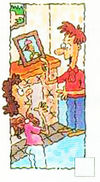 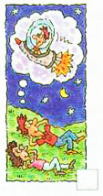 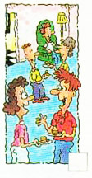

2. Play the recording for the Ss. Ss just listen for the first time. Play the recording again and number the pictures.

3. Play the recording and check the answers with the Ss.

Work on 1d:

1. T: Now please read the sentences in 1d. Tell Ss they'll listen to the tape again. Then try to fill in the blanks with the words in the chart.

|  |
| --- |
| am, live, work, lived, took, will be, will live, will fly |

1) I ____ in an apartment across the street from here.

2) I _____ near here.

3) I ____ a computer programmer.

4) We _____ in a house in the country.

5) I _____ the train to school.

6) I _______ an astronaut.

7) I _______ rockets to the moon.

8) I _______ on a space station.

听力指导： 通过读句子及空格中的单词，可以看出，本听力重点要求我们听清句子的时态，因此我们在听时应重点听句子的谓语动词，并明确其时态。如果不能快速写下来，可以先做标记，在听完后再写完整。

2. Ss listen to the recording carefully and try to fill in the blanks.

3. Play the recording again and check the answers with the class.

4. Tell Ss one is Alexis and the other is Joe. Talk about Joe’s life now, 10 years ago and 10 years from now.

5. Try to retell the conversation.

Ten years ago, Joe ____ with his parents in a house in the country. He _____ the train to school.

Now Joe ____ in an apartment in Highville and _____ near here. He ____ a computer programmer. He thinks it’s kind of boring.

In ten years, Joe thinks he ______ an astronaut. He _______ rockets to the moon. And he _______ on a space station.

6. Role-play the conversations with your partner.

**Ⅴ. Pair work**

1. Work on 1e.

Student A is Alexis and Student B is Joe. Talk about Joe’s life now, 10 years ago and 10 years from now.

2. Write about your and your partner’s life in ten years. Then report it to class.

I’ll be a businessman. I’ll live in a big house. I’ll be away on business by plane.

He’ll be a doctor. He’ll live in an apartment. He’ll walk to work.

**VI. Summary**

1. live in an apartment

2. fly rockets to the moon

3. live on a space station

4. I will be an astronaut.

5. I will fly rockets to the moon.

6. I will live on a space station.

**VII. Exercises**

句型转换。

1. Peter will wash his car this afternoon.  (改为一般疑问句并补全否定答语)

—_______ Peter _______ his car this afternoon?

—No, _______ _______.

2. There will be a prize for the winner of the game. (改为一般疑问句并补全肯定答语)

—_______ _______ _______ a prize for the winner of the game?

—Yes, _______ _______.

3. Next summer Ann will go to the beach on holiday.  (改为否定句)

Next summer Ann _______ _______ to the beach on holiday.

4. Mrs. Smith will have a baby in a few weeks.     (对划线部分提问)

_______ _______ Mrs. Smith _______ a baby?

5. I will stay at my aunt’s home next year.     (对划线部分提问)

_______ _______ you _______ next year?

**Homework**

1. Preview the passage on page 53.

2. Talk about your life now, 10 years ago and 10 years from now.

**Section B2 (2a-2e)**

一、**教学目标：**

**1. 语言知识目标：**

1) 能掌握以下词汇：human, servant, dangerous, already, factory, believe, disagree, even, agree, shape, fall, inside, possible, impossible, side, over and over again, hundreds of, fall down, look for

2) 能掌握以下句型：

Today there are already robots working in factories.

They are fun to watch.

It will be difficult to make them really think like a human.

However, they agree it may take hundreds of years.

Some will look like humans, and others might look like animals.

We never know what will happen in the future！

3) 能综合运用will表达一般将来时态。

**2.** 通过引导学生展望未来及对未来生活的设计，来达到前景教育的目的，同时也通过对前景的设想，让学生在潜移默化中反省自己的现状，使之对目前的学习、生活习惯作适当的调整，并不断的改善自己的现状，使学生的理想观和价值观更为科学，更具发展价值。

二、**教学重难点**

1. 教学重点：

1) 掌握本课时出现的生词及表达方式。

2) 阅读短文，获得相关信息，提高学生们的综合阅读能力。

2. 教学难点

阅读2b部分的短文并完成相关要求。

**三、教学过程**

**Ⅰ. Revision**

**Ⅱ. Warming up**

Do you know where the word “robot” was firstly used?

**Ⅲ. Discussion**

1. Work in groups. Tell your partner what you know about robots. What do they look like and what can they do?

2. Ask some Ss describe the robots they know.

**Ⅳ. New words**

**Ⅴ. Reading**

1. Let Ss read the article and match each paragraph with the question it discusses.

Para.1 Will robots think like humans in the future?

Para.2 What will robots be like in the future?

Para.3 What can robots do today?

Para.4 What are robots like in movies?

2.Work on 2c.

1) Robots can build ____ in factories.

2) They can do _______ jobs many times and never get bored.

3) Some can _________ and _____________.

4) Some can help _______ people under _________.

2. 方法指导：明确我们这次阅读的任务，然后，带着这个任务再次认真阅读短文的内容，并在相关段落中认真查找未来机器人所能做的事情。 并写出正确的答案。

3. Check the answers with the class.

4. Read the article carefully, then complete the table.

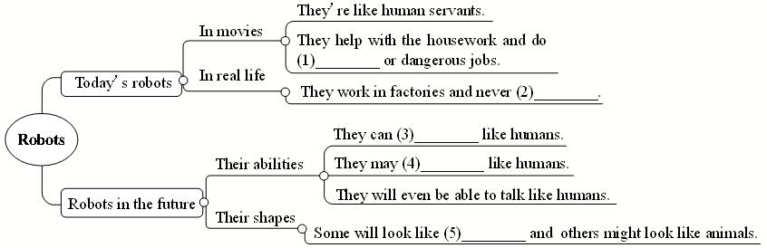

**VI. Reading 2**

1. Work on 2d.

Some robots are very human-like. They can walk and ______ like people. Some scientists think that in the future they will _______ robots more like humans. This may not _______ in the near future, but at some point, robots will even be able to ______ like people. However, some scientists ________. James White believes that robots will not be able to do the _______ things as we can. For example, he thinks that robots will ______ be able to wake up and know where they are. Which side do you ________ with?

2. 方法指导：首先，阅读这个小短文，了解其大意；然后，在理解小短文意思的基础上，重点阅读有空格的句子，并在原文中找与之相关的段落或句子，并填写出正确的答案。

3. Let some Ss talk about their answers.

4. Discussion.

What kind of animals might robots look like in the future? What do you think these robots will be able to do? Write your ideas and role discuss with your partner.

**Ⅷ. Retell the text.**

We sometimes see robots in movies. They are usually like ______ servants. They do jobs like working in dirty or _________ places.

Today there are ________ robots working in ________. Some can help to build cars, and they do simple jobs _________________.

Some scientists _______ that although we can make robots move like people, it _______________ make them really think like a human. But many scientists ___________ this.

They think that robots will ___________ be able to talk like humans.

It may take __________ years to have more robots in the future. These robots ________ many different shapes. In India, scientists made robots look like snakes. If buildings ________ with people ______, these snake robots can help _______ people under the buildings. This was not ________ 20 years ago, but computers and rockets also seemed _________ 100 years ago.

**Ⅸ. Language points**

1. Today there are already robots working in factories.

现在已经有机器人在工厂里干活了。

working in factories的逻辑主语是robots，但这个there be句型中，谓语动词已经有了are，所以work就不能再作本句的谓语动词，而应用-ing形式。

2. Fewer people will do such jobs in the future because they are boring, but robots will never get bored.

辨析such & so

such和so均可表示“如此；这样”。

1) such常用来修饰名词，so常用来修饰形容词或副词。

e.g. Do you like such weather?

I’m so glad to see you.

He can draw so well.

2) 当名词前有many，much，few或little等表示数量的词修饰时，用so不用such。

e.g. There are so many /few people in the hall.

You have so much /little homework today.

3) “such + a / an +*adj*.+可数名词单数”相当于“so +*adj*.+ a /an +可数名词单数”，表示“如此……的一个……”。

e.g. She is such a lovely girl.

= She is so lovely a girl.

【语境应用】用such或so填空。

1) The man told us _____ funny a story.

2) She has _____ a beautiful dress.

3) How can you get _____ much money to buy the car?

4) Don’t go out in _____ cold weather.

5) Don’t eat _____ quickly.

get bored 变得无聊

boring *adj*. 无聊的（主语是物体）

bored *adj*. 令人无聊的（主语是人）

e.g. This book is very ________. 这本书真无聊。

  The children quickly ____________ with staying in the house.

孩子们呆在家里很快变得就无聊了。

3. But many scientists disagree with Mr. White.

However, they agree it may take hundreds of years.

agree *v*. 同意；赞成；应允

disagree *v.* 不同意 ；持不同意见；有分歧

前缀(dis-) + agree (同意)→disagree

agree with sb.  同意某人的意见

agree to do sth.  同意做某事

e.g. I agree _____ you on this matter.

He agreed ____ fly kites with me this weekend.

agree后可接that引导的宾语从句，that有时可省略，意为“同意……；一致认为……”。

e.g. They agree (that) the movie is very boring.

take *vt*. 花费

It takes / took/ will take sb. some time to do sth.

花费某人多长时间做某事

e.g. The problem was difficult. It took Leo nearly twenty minutes to work it out.

hundreds of 数以百计的；成百上千的 后接可数名词复数形式

e.g. There are hundreds of ____ (pig) on the farm.

当hundred受数词或不定数量词修饰时，hundred用零复数形式，即原形。

e.g. 三百 → three hundred

4. Some scientists believe that although we can make robots move like people, it will be difficult to make them really think like a human. (翻译)

一些科学家相信尽管我们可以把机器人做得能像人一样活动，把它们做得真的像人一样思考将会很难。

believe *v.* 相信；认为有可能

believe sb. 相信某人说的话

believe sth.相信某事会发生(或已经发生)。

e.g. I don’t believe you.

believe in 信赖 相信

believe in后接sth.(真理一类的词)多表示信仰某事物，相信其存在；

后接sb.则表示信赖某人或相信某人的人格。

e.g. Do you believe in magic?

We all believe in Mr. Zhang.

【语境应用】根据句意，用believe或believe in的适当形式填空。

1) I ________ what he said just now, but I never __________ him as a person.

2) I couldn’t ________ my eyes when she walked into the room.

Summary

help with the housework 帮忙做家务

in dirty or dangerous places 在肮脏或危险的地方

over and over again 多次；反复地

look like 看起来像

wake up 醒来

disagree with 不同意；不赞成

hundreds of 成百上千；许多；大量

fall down 突然倒下；跌倒；倒塌

look for 寻找；寻求

fly up into the sky 飞向天空

**Ⅹ Exercises**

**Ⅰ. 根据语境，从方框中选择恰当的单词填空, 注意形式变化。**

|  |
| --- |
| already, during, believe, probable, danger, even, side, shape, inside, factory |

1. I couldn’t _______ my eyes when I saw the test results.

2. It’s _______ 9:00 p.m. Let’s go home quickly.

3. She walked home by herself, although she knew it was _______.

4. It’s raining. We will have to go _______ the house.

5. Don’t wash your T-shirt too many times. I’m afraid it will lose its _______.

6. A lot of workers lost their jobs when those two _______ closed (关闭).

7. This painting is good, but that one is _______ better.

8. —Do you think you can do it?

—Well, _______ I can.

9. There are two _______ to every story.

10. They work _______ the night and sleep in the daytime.

**Ⅱ. 根据汉语意思，完成英语句子，每空一词。**

1. 公园里有一座很大的像鸟一样的建筑物。

There is a large _______ _______ in the park.

2. Bob告诉父母他的想法，但是他们和他有分歧。

Bob told his parents about his ideas, but they _______ _______ him.

3. 没有什么好怕的。天不会塌下来。

There is nothing to be afraid of. The sky won’t _______ _______.

4. 她像个机器人一样一遍又一遍地重复它。

She kept repeating it _______ _______ _______ _______ like a robot.

5. 看！图书馆里有许多正在看书的学生。

Look! _______ _______ many students _______ in the library.

6. 昨天那个游泳池里有数以百计的人。

There were _______ _______ people at that swimming pool yesterday.

7. 对我来说，给你一个确定的答复是不可能的。

It’s _______ _______ me _______ _______ you a definite answer.

8. 我们到处找他，但是没有找到。

We _______ _______ him everywhere, but couldn’t find him.

9. 在2030年，他们将在月球上建另一个太空站。

They will build another _______ _______ on the moon in 2030.

**Homework**

If you have a chance to design a robot, what will your robot look like? What can your robot do? How will your robot help you in your life? Write down your ideas.

**Section B 3 (3a-Self check)**

一、**教学目标：**

1. 掌握生词: probably, during, holiday, word

复习用will表达一般将来时态的用法。结合机器人这一话题表达自己的想法。能够综合运用所掌握的知识来描述自己未来生活的情况。

通过自己描述自己未来生活的情况来达到熟练运用所学知识的目的。

2. 通过引导学生展望未来，及对未来生活的设计，来达到前景教育的目的，同时通过对前景的设想，让学生在潜移默化中反省自己的现状，使之对目前的学习、生活习惯作适当的调整，并不断的改善自己的现状，使学生的理想观和价值观更为科学，更具发展价值。

二、**教学重难点**

1. 教学重点：

1) 能运用所学的知识及提示来阅读相关个人未来生活预测，并能完成相关任务。

2）能运用所学的知识与句型来描绘一下自己未来的生活。

3）复习单元所学的重点知识点，并完成相关复习任务。

2. 教学难点：

能运用所学的知识与句型来描绘一下自己未来的生活。

**三、教学过程**

**Ⅰ. Revision**

Fill in the blanks with the right words.

Today there are _______ robots working in ________. For example, they can help to ______ cars, and they do ______ jobs over and over again. They do jobs like working in dirty or _________ ______. Fewer people will do such jobs in the future because they are boring, but robots will never get ______. Some scientists _______ that there will be more robots in ________ ______ years. They are trying to make robots look like ________.

**Ⅱ. Activate and share**

What will you be when you grow up?

How will you go to work in the future?

What kind of pets will you keep?

**Ⅲ. Reading**

1. Read the article about Jill’s life in the future. Fill in the blanks with the words in the box.

2. 阅读指导：

首先，阅读短文，整体把握短文大意。

其次，分析有空格的每个句子，看空格处的意思，联系所给单词的意思，进行综合分析，确定空格处应填的单词。例如：第一空，由下文“在那座城市里有更多的工作”，可知本空填live“居住”一词。

最后，再通读一遍短文，看是否通顺合理。

meet work live look keep wear more less fewer take

In 20 years, I think I’ll be a newspaper reporter. I’ll _________ in Shanghai, because there will be _________ jobs in that city. As a reporter, I think I will _________ lots of interesting people, so I’ll have more friends. I’ll have __________ pets, though, because I’ll have __________ free time. And my apartment will be no good for pets because it’ll be too small.

So I’ll *probably* just _________ a bird. *During* the week, I’ll _________ smart clothes. On the weekend, I’ll _________ less smart but I’ll be more comfortable. In the future, people will _________ more so they’ll probably have fewer vacations, but I think I’ll __________ a *holiday* in Hong Kong when possible. One day I’ll even go to Australia.

3. Ss try to read the article and try to fill in the blanks.

4. Check the answers with the Ss.

**Ⅳ. Writing**

Work on 3b:

1. Think about your life 20 years from now. Write down some notes in the chart below.

You can add more items.

2. Give some examples to the Ss.

3. Ss try to think about their lives 20 years from now.

4. Try to fill in the blanks.

Work on 3c

1. Write about your life 20 years from now using the notes in 3b.

2. 写作指导：

* 本文为写自己未来20年后的生活情况。
* 因此，时态应用一般将来时态（will + 动词原形）；
* 首先，可根据在3b中的提示，介绍一下自己打算的工作、及生活的地点、自己的业余活动等情况。
* 然后再展开自己想象的翅膀，对自己的生活环境及其他方面大胆想象，并写出来。
* 最后，通读一遍短文，重点检查一下各句子的时态及语句是否通顺。

**【写作任务】(Section B 3c)**

本周你校要进行有关畅想未来的英语演讲比赛。请以“My life in 20 years”为题，从20年后你所从事的职业、居住地周围环境、业余活动等方面畅想，写一篇演讲稿为此次比赛做准备。

**【思路点拨】**

**1. 定基调**

体裁：应用文(演讲稿)；演讲稿的主体部分为说明文

时态：一般将来时

人称：第一人称

**2. 谋布局、写句子**

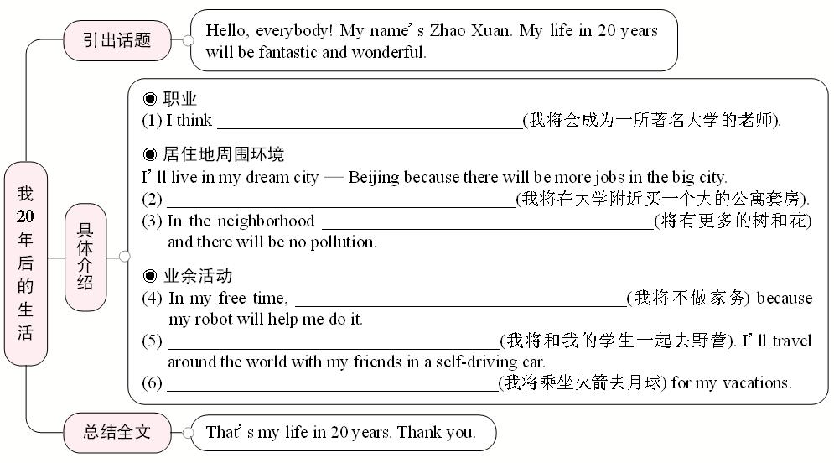

**3. 巧衔接**

本文要描述自己20年后的生活，自然会多次用到句型I will ...，这种平行结构的重复使用可以达到连接上下文的目的。另外，本文是从不同角度畅想未来生活，所以可用and, then, even, what's more等表示语义增进，以使行文过渡自然、流畅。

**4. 成篇章**

Hello, everybody! My name's Zhao Xuan. My life in 20 years will be fantastic and wonderful. ____________________________________________________________

__________________________________________________________________________________________________________________________________________________________________________________________________________________That's my life in 20 years. Thank you.

4. 成篇章

Hello, everybody! My name's Zhao Xuan. My life in 20 years will be fantastic and wonderful. I think **I will** be a teacher in a famous university.**And** **I will** live in my dream city — Beijing because there will be more jobs in the big city. **Then** **I will** buy a big apartment near my university. In the neighborhood there will be more trees and flowers and there will be no pollution. In my free time, I won't do the housework because my robot will help me do it. **I will** go camping with my students. **I will** **even** travel around the world with my friends in a self-driving car. **What's more,** **I will** fly rockets to the moon for my vacations.

That's my life in 20 years. Thank you.

3. 学生们根据写作提示，及上面表格中的提示来写作这篇文章。

Sample:

In 20 years, I think I'll be a teacher. I'll live in Xi'an, because it's a wonderful city. Lots of people from China and other countries visit that city, so I'll meet lots of interesting people. I'll live in an apartment near my school so I don't have to travel much. I may have more free time, so I'll spend more time with my friends. I'll see them on the weekend and we'll play soccer every Saturday. We'll also do some other interesting activities together, such as hiking in the national parks.

4. Let some Ss read their passage to the class.

**Ⅴ. Discussion**

1. Discuss how a robot will help students with schoolwork in the future. Write down your group’s ideas and draw a picture of your robot.

2. Give Ss an example:

I think students won’t need write words on the paper because robots will write down everything you think.

3. Ss discuss with their partners and try to draw the robots they think about.

4. At last, let some Ss talk about their robots and pictures of the robots.

**Ⅵ. Self check**

**Work on Self check 1**

1. Put the words in the correct columns in the chart.

2. 引导学生们复习more/fewer/less 的用法：

more后面可跟可数名词或不可数名词；

fewer后面跟可数名词；

less 后面跟不可数名词；

4. 学生将以上单词分类，并校对答案。

5. 学生们可以试着多增加一些单词，并将它们填写在方框中。

**Work on Self check 2**

1. Tell Ss to read the conversation below. Then Fill in the blanks in the conversation.

2. Do the first one for the Ss as a model:

(1. be; like在本句中是介词，意为“像”，因此本句中缺少be动词，句中有情态动词will，故应用be动词的原形。)

3. Ss try to fill in the blanks with the right words.

4. Check the answers with the class.

**Ⅶ. Summary**

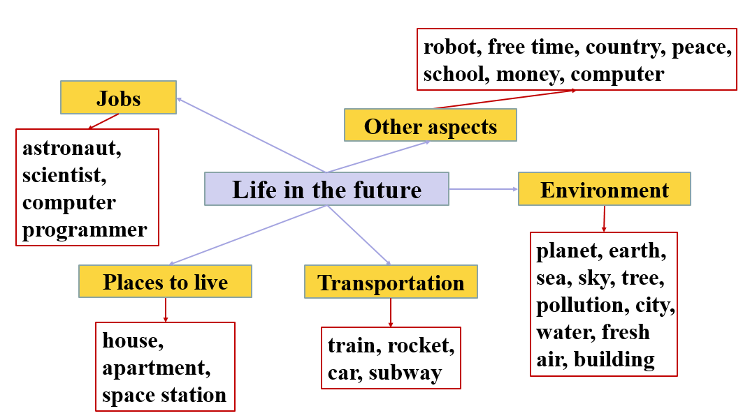

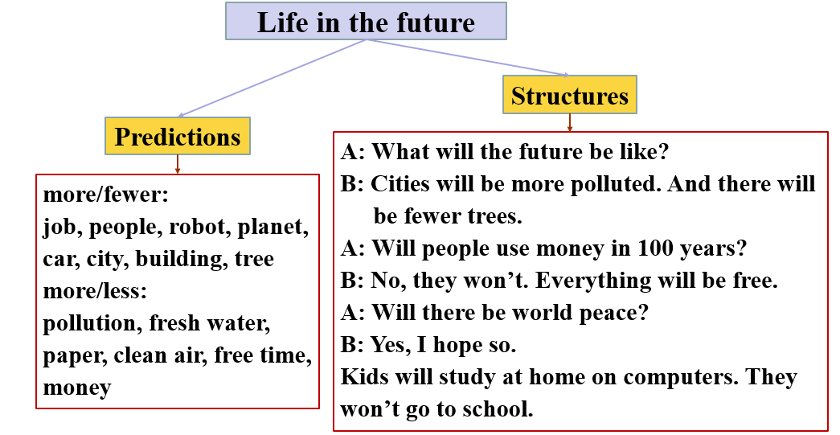

**VIII. Exercises**

**根据短文内容，从方框中选择恰当的单词填空，注意形式变化。每词限用一次。**

|  |
| --- |
| earth, danger, planet, during, rocket, plant, possible, agree, build, believe |

On May 30, 2020, a private (私人的) American company (公司) named SpaceX succeeded (成功) in sending two astronauts into space by using its own (1)_______. This is the first time in history that a private company has sent astronauts into space. So let’s spend some time learning about the founder (创办者) of this company. It is Elon Musk.

He was born (出生) in South Africa in 1971. When he was 17, he moved to Canada. Four years later, he went to study at a famous university in the USA. (2)_______ his study at university, he became interested in space. He dreamed of living on Mars (火星), another (3)_______ in our solar system (太阳系). To him, nothing was more exciting than living on Mars. To make his dream come true, he worked hard to make money after university. By June 2002, he had already made enough money to set up his own company SpaceX.

Elon Musk (4)_______ that humans will live on Mars in the future. Now he is planning (5)_______ a city on Mars. In the city, people will be able to (6)_______ trees and grow vegetables. However, many people (7)_______ with him. They think that it is (8)_______ for humans to live on Mars, because it is too far away from (9)_______. Some people even think it may be (10)_______ to live on Mars because it is too cold there.

**Homework**

Finish your writing about your life 20 years from now. If you have finished writing in class, do make some improvements.